The file explanation for Android system integrate to Ali cloud
- Import library
Add below information under item “build”：
implementation group: 'com.aliyun', name: 'tea-openapi', version: '0.2.2'
implementation group: 'com.aliyun', name: 'iot20180120', version: '3.0.3'

- Add the following information under the “application” tag of AndroidManifest.xml:
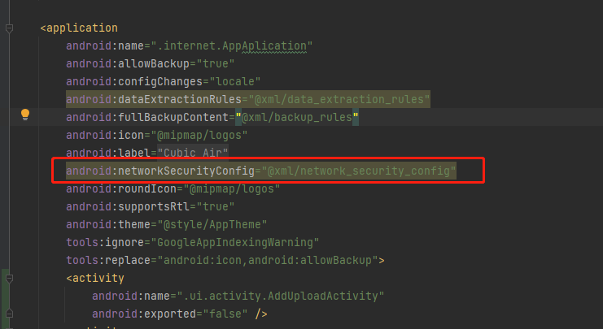

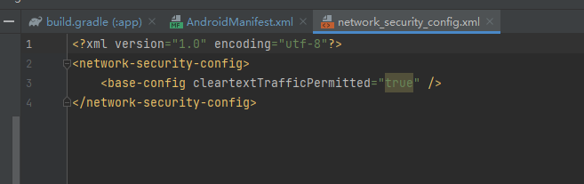

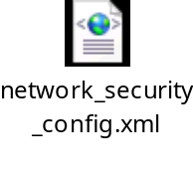

- Get network data
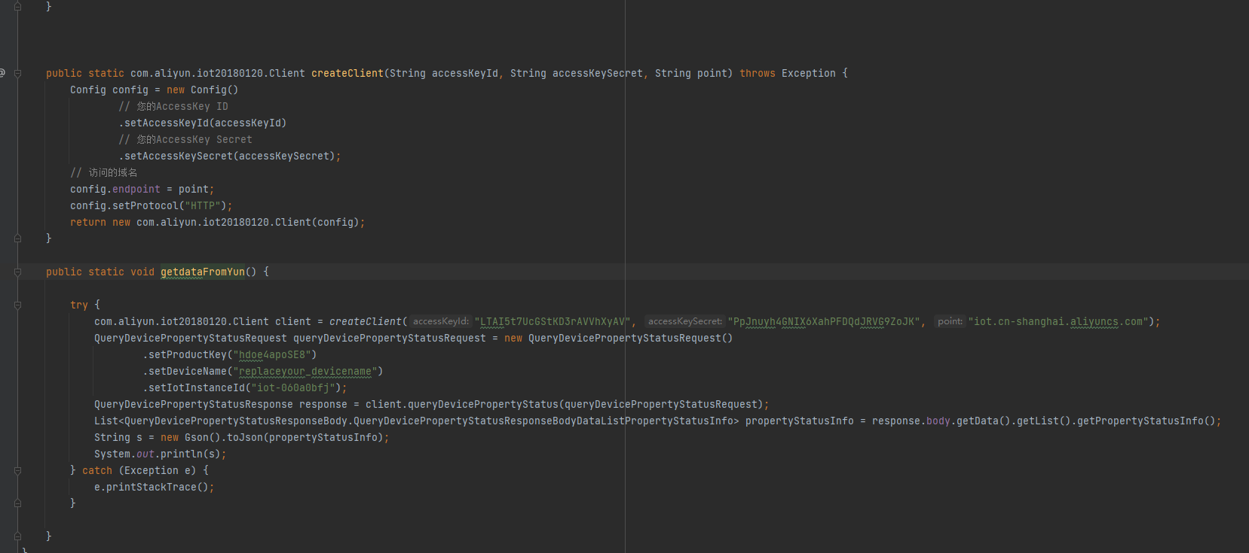

The accessKeyId、accessKeySecret、point、ProductKey、IotInstanceId need to be viewed in customer own Ali cloud background instance. For example, the meaning of the “point” as below:

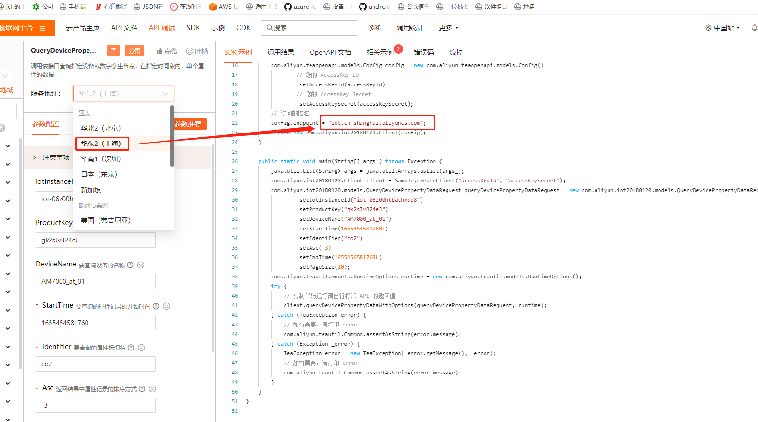

Operation address:
https://next.api.aliyun.com/api/Iot/2018-01-20/QueryDevicePropertyData?spm=5176.smartservice_service_chat.0.0.2b063f1b9BONQ0&lang=JAVA&params={%22IotInstanceId%22:%22iot-06z00htbathxdq8%22,%22ProductKey%22:%22gk2sJvB24eJ%22,%22DeviceName%22:%22AM7000_at_01%22,%22StartTime%22:1655454581760,%22Identifier%22:%22co2%22,%22Asc%22:-3,%22EndTime%22:1655456581760,%22PageSize%22:20}&sdkStyle=dara&tab=DEMO

DeviceName for user to create an device name in the project instance.

If there is no problem, then the printed log will have content.

